Deloitte Case Study

***Wireframe Documentation***

**Dashboard**

1st page Annually data dashboard of different country

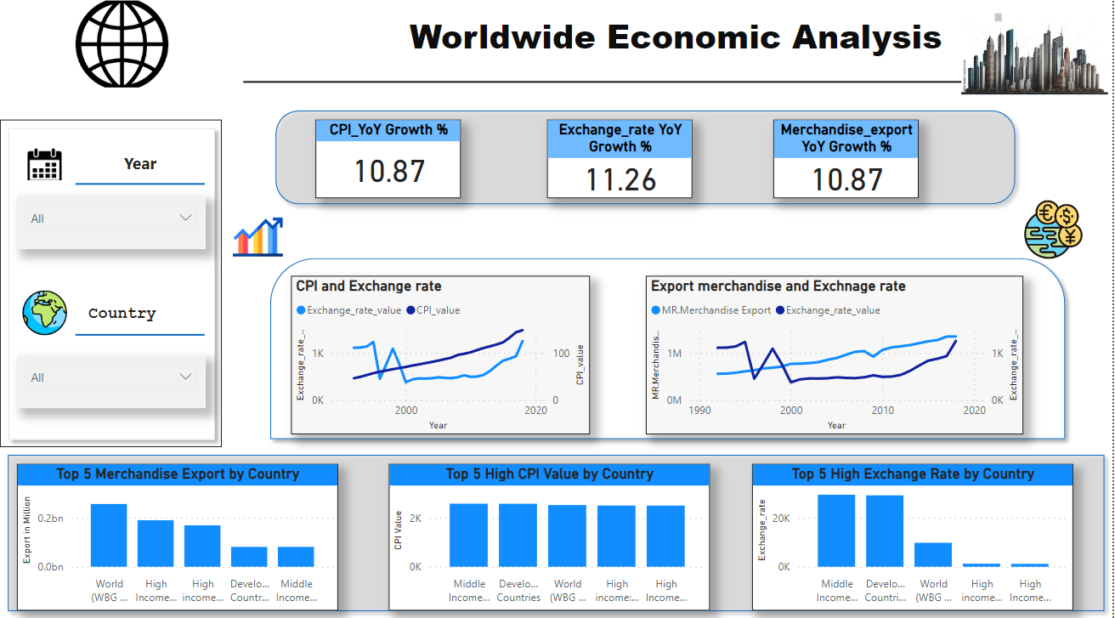

2st page Monthly data dashboard of different country

